Projectiles Qs

1. A stone is thrown horizontally at 15 ms⁻¹ from the top of a cliff which is 30 m above the sea.
a) How far out at sea does it land?
b) How fast must the tone be thrown if it is to land on top of a floating piece of wood 25 m from
the base of the cliff
c) How long will it take to strike the wood?
d) With what velocity will it strike?

- You are wiping the surface of the main dining table at home after a meal, when quite accidentally you strike a fork that then slides off the table at a horizontal speed of 3.70 ms⁻¹. If the fork lands on the ground, 1.36 m horizontally from the edge of the table, how high off the ground is the top of the table?

1.36 m

3. A Channel 7 helicopter is ascending vertically at 4.00 ms^{–1} whilst travelling forward at 16.0 ms^{–1}. When the helicopter is 110 m above the ground the news cameraman accidentally drops his camera out of the helicopter.

a) How long does it take for the camera to reach the ground?
b) What was the maximum height of the camera above the ground?
c) How far forward does the camera travel before landing on the ground?

4.
40⁰
Big Bertha was the name of a huge cannon used by the Germans in the First World War to fire across the Channel to England.
This gun was mounted on a train and could be moved to different positions.
The shell’s muzzle velocity was 750 kmh⁻¹.

- If the gun were angled at 40⁰ to the horizontal what would be the shell’s velocity measured along the ground?
- What would be the maximum height that the shell reached above the ground?
- What is the range of the gun at 40⁰?
- What would be the gun’s maximum range?
- What would be the velocity and angle of the shell 5 seconds after firing?
5. In training, a baseball batter hits a ball at a speed of 22 ms⁻¹ and an angle of 41⁰ towards a vertical metal fence that is 35 m away.
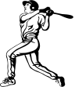
22 ms⁻¹
41⁰
35 m

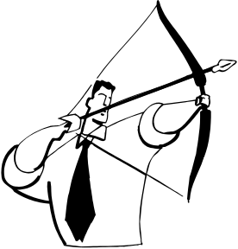
- How far from the ground does his ball strike the fence?
- At what angle does it strike the fence?

6. Jonathon, a world class archer, is shown preparing to shoot an arrow. At the instant of release, the 0.050 kg arrow has a velocity of 28.5 ms⁻¹ at an angle of 30⁰ to the ground. The arrow is 1.40 m from the ground when released.

(a) Calculate the vertical and horizontal components of the arrow’s initial velocity.
(b) How far away from Jonathon does the arrow hit the ground?

(c) (No calculations are required for the following)
- Sketch the trajectory of the arrow on a graph
Label this i)
- Sketch on the graph the trajectory of the arrow showing how it would be changed if you allowed for air resistance. Label this ii)
Explain why the trajectory changes in this way.
(iii) Sketch on the graph the path of the arrow if it is fired at an angle of 40⁰ rather than 30⁰ (neglecting air resistance). Label this iii)

7. In the movie Car Escape, Taylor and Jones drove their sports car across a horizontal car park in building 1 and landed it in the car park of building 2, one floor lower. Building 2 is 20 metres from building 1, as shown in the diagram. The floor where the car lands is 4.0 m below the floor from which it started in building 1. In the following questions, treat the car as a point particle and assume that air resistance is negligible.
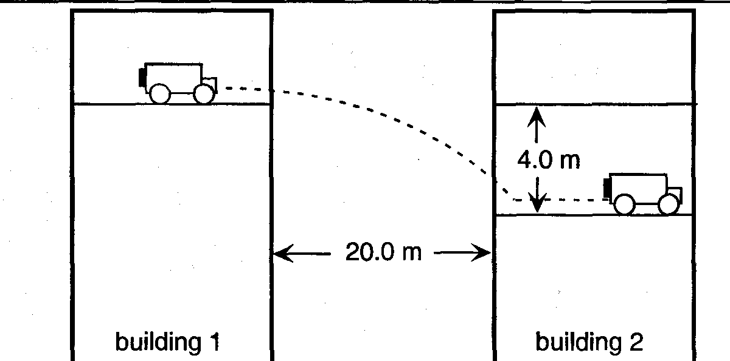
a) Calculate the minimum speed, at which the car should leave building 1 in order to land in the car park of building 2. Show your working.
b) In order to be sure of landing in the car park of building 2, Taylor and Jones, in fact, left building 2 at a speed of 25 ms^{–1}. Calculate the magnitude of the velocity of the car just prior to landing in the car park of building 2.

8. A skateboarder rides up a ramp as shown in the diagram below. At the instant the skateboard leaves the ramp, the centre of mass of the skateboard and rider is 1.20 m above the ground (as shown) and is initially moving with a speed of 5.00 ms⁻¹, at an angle of 30.0° above the horizontal. The parabola XYZ is the path of the centre of mass of the skateboard and rider. Assume that air resistance is negligible.

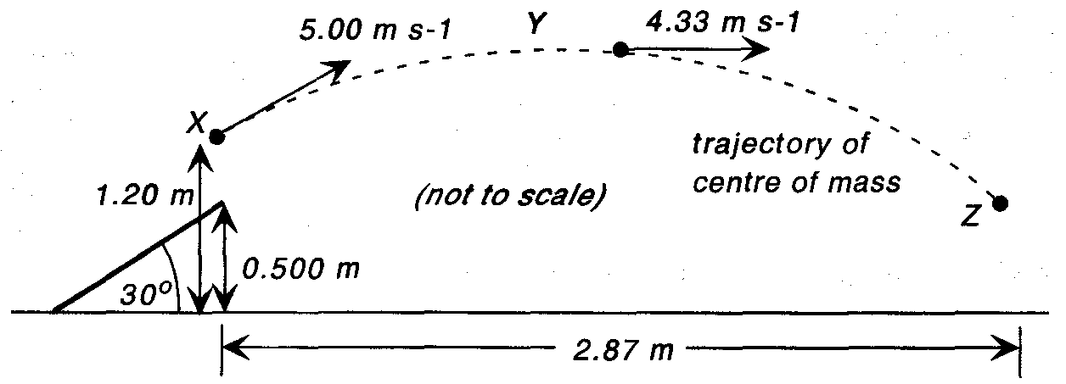
Range

a) Calculate the height above the ground of the centre of mass at the highest point of the motion (Y).

b) When the skateboard touches the ground the centre of mass has moved has moved to point Z, as shown above. Calculate the time that the skateboarder is airborne.

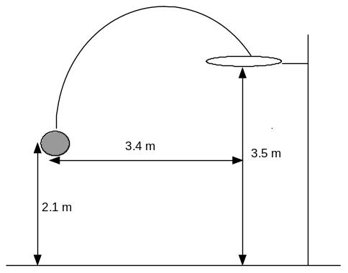
9. A game of netball is being played in the gymnasium. A goalie shoots for a goal as described in the diagram that follows. The ball takes 1.1 s to travel the trajectory shown.

(a) What is the launch speed of the ball?

(b) At what angle to the horizontal was the ball launched?

(c) Throughout the flight the ball's horizontal component remains constant. What does this indicate about the atmospheric conditions that exist within the gymnasium?

(d) The following weekend the same goalie is required to launch a ball in the same situation as before but this time she is playing on an outside court where there is a horizontal crosswind of 2.0 m s⁻¹ blowing. (This is wind that blows at 90˚ to the direction of the throw). Calculate the adjustment to the horizontal component and the vertical component of the throw's velocity that would need to be made, in order to successfully score a goal.

10. A soccer player kicks a ball from ground level at an angle of 40.0^{O} to the horizontal
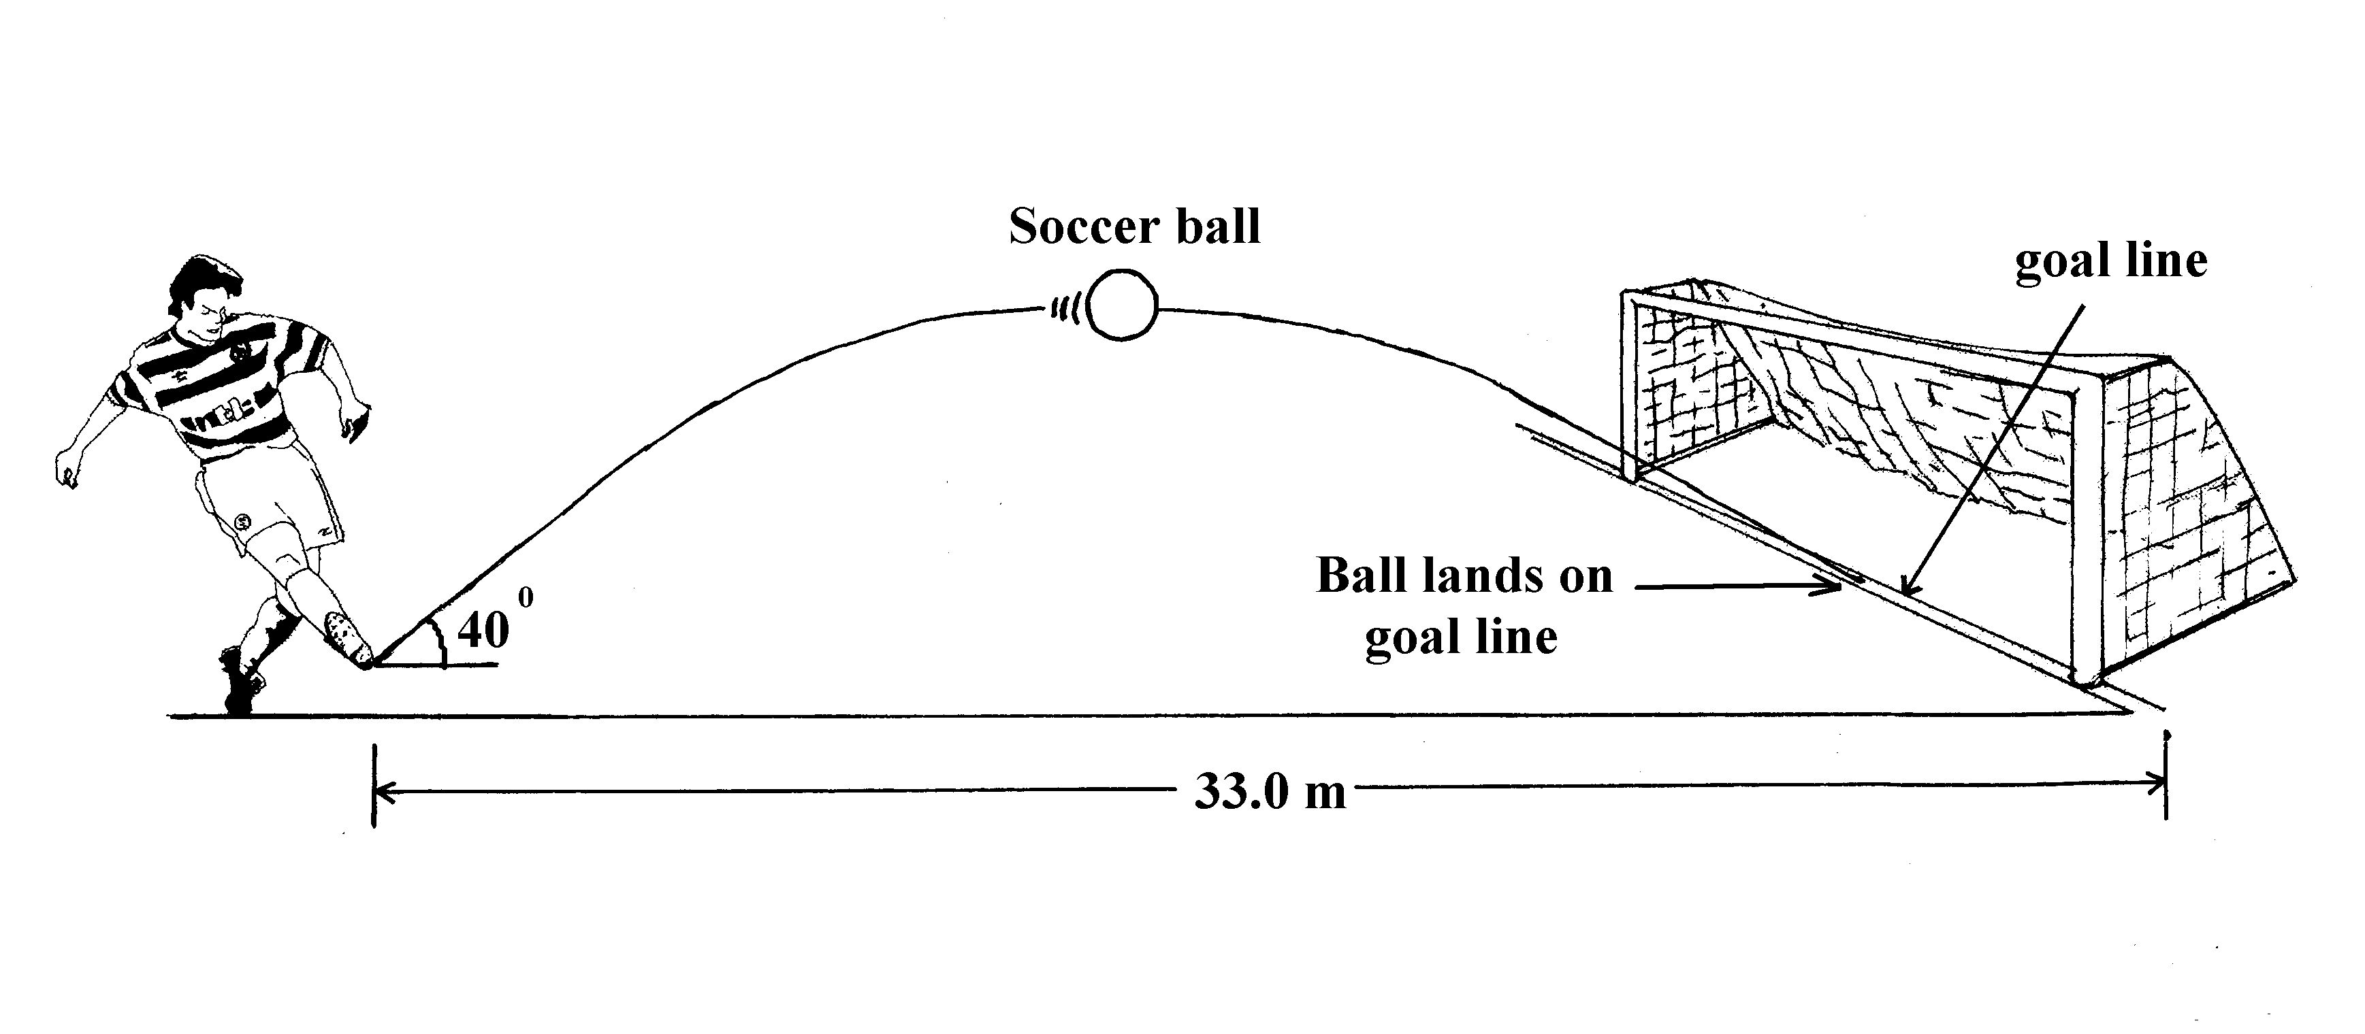
in an attempt to score a goal. The goals are 33.0 m away. The ball lands on the goal line
and bounces into the goals. See the diagram below.

a) With what velocity does the ball leave the player’s boot? (ignore air resistance)
b) What is the time of flight of the ball?
c) What is the highest point above the ground that the ball reaches?
d) At what horizontal distance from the kick off point does the ball reach its maximum height?

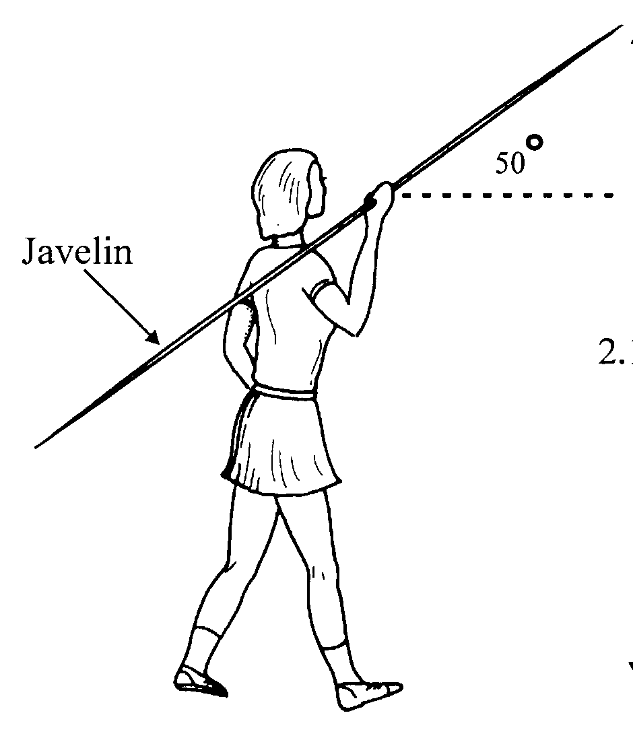
11. Deanne, a world class javelin thrower, is shown preparing to throw. At the instant of release, the 0.600 kg javelin has a velocity of 27.5 ms⁻¹ at an angle of 50.0° to the ground. The javelin is 2.10 m from the ground when released.

(a) How long is it before the javelin reaches its maximum height?
(b) What height above ground level does the javelin reach?
(c) How far away from Deanne does the javelin hit the ground?

(d) (No calculations are required for the following:
(i) Sketch the trajectory of the javelin on the graph below. Label this i.

(ii) Sketch on the graph the trajectory of the javelin showing how it would be changed if you allowed for air resistance. Label this ii. Explain why the trajectory changes in this way.
(iii) Sketch on the graph the path of the javelin if it is thrown at an angle of 45° rather than 50° (neglecting air resistance). Label this iii.

12. A diver wishes to make a difficult high dive from a cliff top into the water 6 metres below (see diagram). She always pushes off with zero vertical velocity. One problem is that the water is only deep enough to dive into when a large wave is directly below her. She must hit the water at the instant when the water level is at its maximum if she is to avoid injury.
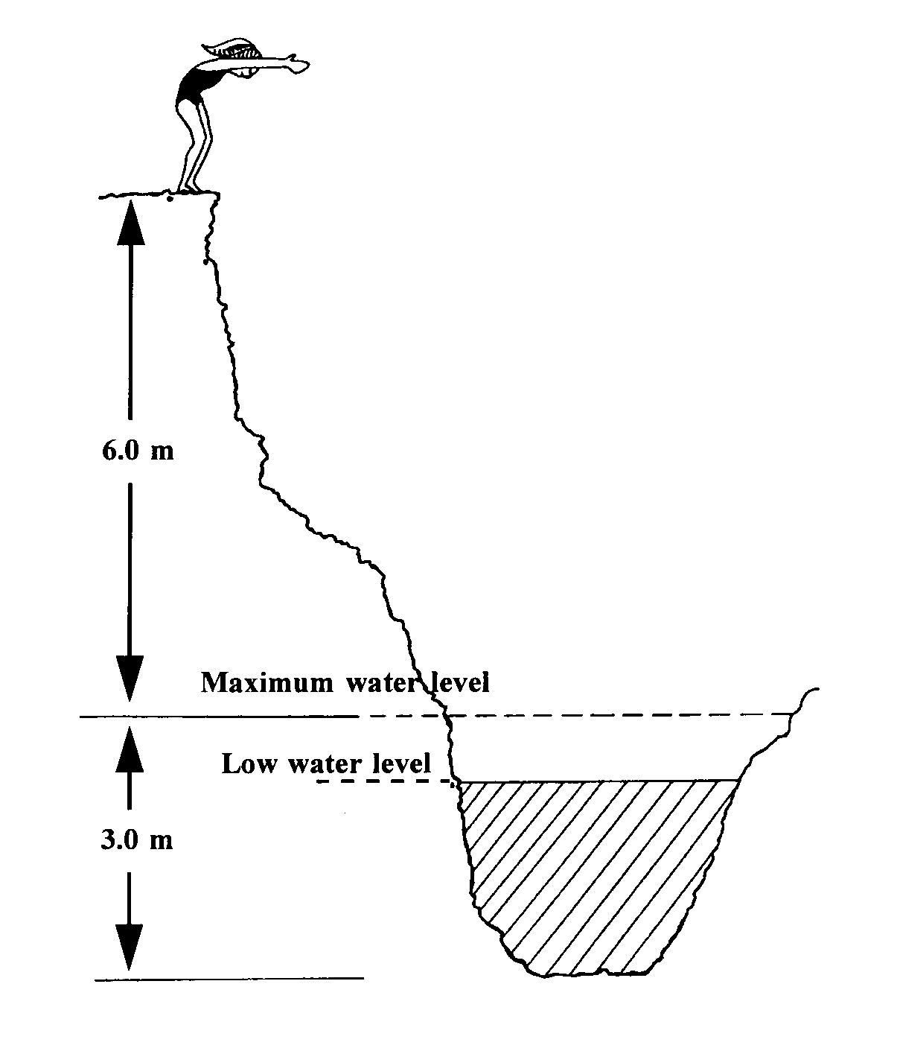

(a) How long before the large wave arrives should she jump from the cliff top?

Another problem is that if she pushes off with too little horizontal speed she will land on the base of the cliff that she is standing on, while if she pushes off with too much horizontal speed she will land on some rocks on the other side of the water. She needs to travel 2.5 metres in the horizontal direction during her dive to land safely in the water.

(b) What horizontal speed should she push off with?
(c) Calculate her speed and direction when she hits the water.

13. In a football game, a place kicker kicks a football 36 m from the goalposts, and the ball must clear the crossbar which is 3.1 m from the ground, as shown in the diagram.

When kicked, the ball leaves the foot at 20 m s⁻¹ at an angle of 53º to the horizontal.
- How long does it take the ball to travel the distance to the goalposts?
- How far above or below the crossbar is the ball when it passes through the goal posts?
- Show on a sketch the path of the football. Include the goalposts in your sketch. Explain why you have drawn the path this way, showing any necessary working.
Solutions to Projectiles Questions set 3
1. a) Vertically: s = ut + ½at²
-30 = 0 – 4.9t²
t² = 6.122 s t = 2.474 s
Horizontally: s = ut = 15 x 2.474 = 37.1 m
b) The stone will still take the same time to fall
s = ut 25 = u x 2.474
v = 10.1 ms⁻¹
c) Vertically: s = ut + ½at²
-30 = 0 – 4.9t²
t = 2.474 s
24.2
10.1
R
θθ
d) Vertically: v = u + at
v = 0 – 9.8 x 2.474 = 24.24 ms⁻¹
Horizontally v = 10.1 ms⁻¹
R² = 24.24² + 10.1 ² R = 26.3 ms⁻¹
Tanθ = 24.24/10.1 θ = 67.4

2. Horizontally: Time of flight = 1.36/3.70 = 0.3676 s
Vertically: s = ut + ½at²
s = 0 - 4.9 x 0.3676² = 0.662 m
3. Vertically:
u = 4 s = ut + ½at²
t = ? -110 = 4t – 4.9t²
a = -9.8 Solver: t = 5.16 s
s = -110
b) Vertically:
u = 4 v² = u² + 2as
v = 0 0 = 4² – 19.6 s
a = -9.8 s = 0.816 m
s = ? Total height = 110 + 0.816 = 110.816 m
c) Horizontally: s = ut = 5.16 x 16 = 82.6 m
4. v = 750/3.6 = 208.3 ms⁻¹
a) u_{H} = 208.3cos40 = 160 ms⁻¹

b) Vertically:
u_{v} = 208.3sin40 = 133.9 ms⁻¹
v² = u² + 2as
0 = 133.9² – 19.6s
s = 915 m
- Vertically:
u = 133.9
a = -9.8
t = ? s = ut + ½at²
s = 0 0 = 133.9t – 4.9t²
t = 133.9/4.9 = 27.32 s
Horizontally: s = ut = 160 x 27.32 =- 4.37 x 10³ m
- Max range when the angle is 45º so u_{v} = u_{H} = 208.3sin45 = 147.3 ms⁻¹
Vertically: s = ut + ½at²
0 = 147.3t – 4.9t²
t = 30.05 s
Horizontally s = ut = 147.3 x 30.05 = 4.43 km
160
84.9
V_{R}
θ
84.9
V_{R}
θ
- Vertically: v = u + at
v = 133.9 – 9.8 x 5 = 84.9 ms⁻¹
Horizontally v = 160
V_{R} = 160 ² + 84.9² V_{R} = 181 ms⁻¹ θ = 28.0º

5. a) u_{v} = 22sin41 = 14.43 ms⁻¹ u_{H} = 22cos41 = 16.60 ms⁻¹
Horizontally: 35 = 16.6t so t = 2.108 s
Vertically: s = ut + ½at² s_{v} = 14.43 x 2.108 -4.9(2.108)² = 8.64 m
b) Vertically: v = u + at = 14.43 – 9.8 x 2.108 = -6.228 ms⁻¹
tanθ = 6.228/16.6 θ = 20.6º
6. a) u_{v} = 28.5sin30 = 14.25 ms⁻¹ u_{H} = 28.5cos30 = 24.68 ms⁻¹
16.6
-6.23
V_{R}
θ
b) Vertically:
s = ut + ½at² -1.4 = 14.25t-4.9t² Solver: t = 3.00 s
Horizontally: s = 24.68 x 3 = 74.1 m
c)
(i)
(iii)
(ii)

7. a) Vertically: s = ut + ½at²
-4 = 0 – 4.9t² t = 0.9035 s
Horizontally: s = ut so 20 = u x 0.9035 = 22.1 ms⁻¹
25
-8.84
V_{R}
θ
- Vertically: v = u + at = 0 + 9.8 x 0.9035 = 8.854 ms⁻¹
V_{R} = 25² + 8.84² so V_{R} = 26.5 ms⁻¹
8. a) Vertically: u_{v} = 5sin30 = 2.5 ms⁻¹ u_{H} = 5cos30 = 4.33 ms⁻¹
v² = u² + 2as 0 = 2.5² – 19.6s
s = 0.319 m above X so s_{m} = 1.519 m above the ground.
b) Height of z is 1.2 – 0.5 = 0.70 m so height fallen = 0.50 m
s = ut + ½at² -0.5 = 4.33t – 4.9t² t = 0.987 s
9. a) Horizontally: s = 3.4 t = 1.1 so u_{H} = 3.4/1.1 = 3.09 ms⁻¹
b) Vertical height difference = 3.5 – 2.1 = 1.4 m
Vertically: s = u_{v}t + ½at² so 1.4 = u_{v} x 1.1 – 4.9(1.1)²
3.09
5.39
V_{R}
θ
7.329 = u_{v} x 1.1 so u_{v} = 6.66 ms⁻¹
Tanθ = 6.66/3.09 θ = 65.1º
- If u_{H} is constant then air resistance is negligible (no wind)
- Assuming the same angle of launch:
Ball must follow the same horizontal and vertical path with same velocities. Horizontally:
3.09
2.0
V_{R}
θ
V_{R}² = 2² + 3.09²
So V = 3.68 ms⁻¹
tanθ = 2/3.09 θ = 32.9^{O}
NB the vertical velocity is not affected by the wind so it will remain the same.

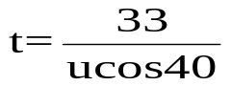10. a) Horizontally: u_{H} = ucos40 = 33/t so
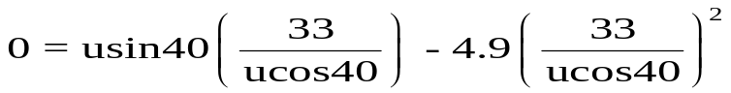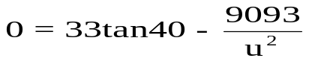 Vertically: s = u_{v}t + ½at²

u = 18.1 ms⁻¹
b) t = 33/(18.1cos40 = 2.38 s
c) v² = u² + 2as so 0 = (18.1son40)² – 19.6s s = 6.91 m
d) Time when at max height = 2.38/2 = 1.19 s
s = 18.1cos40 x 1.19 = 16.5 m ( half-way, as expected)
11. a) Vertically: u = 27.5sin50 = 21.07 ms⁻¹
v = u + at at top 0 = 21.07 – 9.8t
t = 2.15 s
b) v² = u² + 2as
0 = 21.07² – 19.6s
s – 22.65 m above launch height.
Displacement from the ground = 22.65 + 2.10 = 24.8 m
c) Vertically: To find the time of flight when s = -2.10 (ground)
u = 21.07
a = -9.8 Using s = ut + ½ at²
s = -2.10 -2.10 = 21.07t –4.9t²
t = ? Solving for t: t = 4.403 s
Horizontally: s = u_{H}t
s = 27.5cos50 x 4.403 = 77.8 m
24.7
2.1
(i)
(iii)
(ii)
d)

For graph ii) air resistance reduces the vertical and horizontal KE and so the javelin has less range and a lower maximum height.
12. a) Vertically: s = ut + ½ at²
6 = 4.9 t² t = 1.11 s
She needs to dive 1.11 s before the wave arrives to enter at the maximum wave height.
b) She would need a horizontal velocity of v_{H} = 2.5/1.11 v_{H} = 2.26 ms⁻¹
c) Vertically: v_{v} = u + at
= 0 + 9.8 x 1.11 = 10.88 ms⁻¹
Horizontally: v_{H} = 2.26 ms⁻¹
2.26
10.88
V
From the vector triangle: v² = 10.88² + 2.26² v = 11.1 ms⁻¹
tanθ = 10.88/2.26 so θ = 78.3⁰
13. Horizontally: v_{H} = 20cos53 = 12.04 ms⁻¹
Time to travel 36 m = 36/12.04 = 2.99 s
a) To find height 36 m away:
Vertically
u = 20sin53 = 15.97 ms⁻¹
a = -9.8 ms⁻² Using s = ut + ½ at²
t = 2.99 s s = 15.97 x 2.99 – 4.9(2.99)²
s = 3.95 m above the ground so the ball clears the bar by 0.85 m
b) vertical time of flight: s = ut + ½ at²
0 = 15.97t – 4.9t²
t = 15.97/4.9 = 3.26 s
Range = 12.04 x 3.26 = 39.2 m
Max vertical height when v = 0
v² = u² + 2as so 0 = 15.97² – 19.6s range s = 13.0 m

Trajectory:
39.2 m
3.1 m
Crossbar
13.0 m

